Huddle Topic
Blood Culture Draw Technique
Purpose: Reduce Blood Culture Contamination

Prevent Blood Culture Contamination by following these steps for every blood culture draw:
- Perform hand hygiene and don clean gloves
- Pop the caps of 1 aerobic and 1 anaerobic bottle
- Scrub the bottles’ septums for 30 seconds with 70% Alcohol swab. Do not place in the bed.
- Wrap tourniquet
- Find your vein – DO NOT DRAW FROM ANY LINE. Line drawns can lead to:
- Contamination due to culturing biofilm on the line
- False positive results Misdiagnosis

- Inappropriate treatment
- Scrub skin with Chloraprep/CHG for 60 seconds, then air dry for 60 seconds
- If drawing from a moist area scrub for 2 minutes and dry for 1 minute
- DO NOT TOUCH THE AREA YOU SCRUBBED
- Use the Kurin/Steripath device to draw blood into bottles
- Fill bottles alphabetically: Green (aerobic) THEN Orange (anaerobic)
- Date /Time/Initial/Source
- Place both bottles in 1 biohazard bag

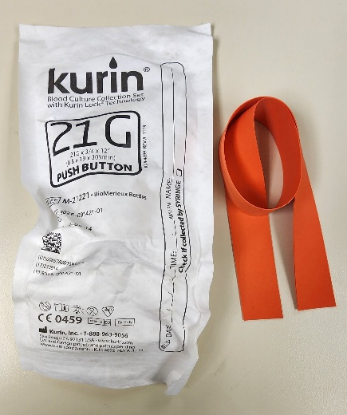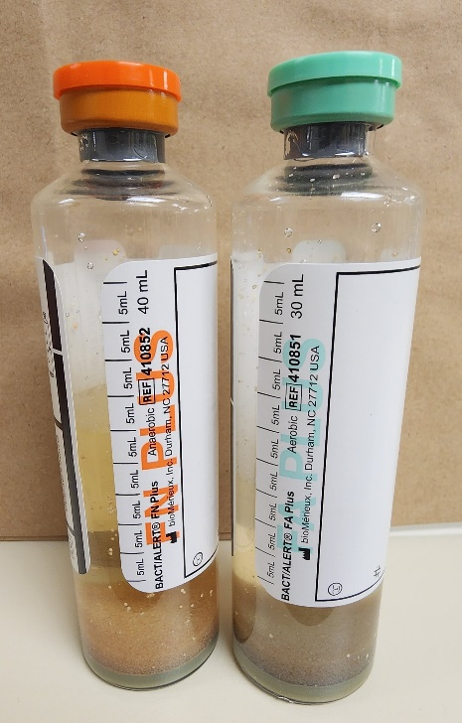

Date of Distribution:10/26/2022 Intended Audience: Nursing, Phlebotomy
Direct Questions to: Infection Control

